Project Work Plan

# Dataset(s) Used

We are planning to analyze the Open Sourcing Mental Illness dataset. The dataset is a survey done on mental health in the technical industry at various locations. It has about 63 questions and over 1400 responses.

Open Sourcing mental Illness, LTD (2016). *OSMI* (Version 1) [Data file]. Retrieved September 7, 2018, from <https://osmihelp.org/research>

Since mental health disorders are often surrounded by harmful stigma, many workers suffer silently. This dataset provides information about employee perceptions about mental health in the workplace, including mental health coverage and services offered, how comfortable an employee is with disclosing issues with mental illness, and perceived impact of mental health illness on their careers. We believe that analysis on this dataset can help us answer some interesting questions. The results could provide insights about the impact of employer policies on employee behavior and perceptions regarding this important issue. In addition, this dataset can help us learn more about the nature of mental health stigma in the workplace.

# Draft Research Questions

1. Is there a relationship between company size and provision of mental health benefits as part of healthcare coverage?
2. Is there a relationship between company size and whether the employers offer resources to learn more about mental health concerns and options for seeking help?
3. What determines whether an employee feels that asking for medical leave from work would be difficult or very difficult?
4. What determines whether an employee feels that discussing a mental health disorder with your employer would have negative consequences?
5. Is there a relationship between the company's support for helping workers with mental health conditions and workers willingness to reach out for help?
6. What is the distribution of geographic locations in the dataset?
7. What is the distribution of mental health status among genders in the dataset?
8. What are the most common Mental Health Disorders that survey respondents have been diagnosed with in the dataset?
9. Is there a relationship between mental illness and perceived productivity according to the employees?
10. Do employees see a relationship between their colleagues’ mental illness and their productivity at work?
11. Is there a relationship between perceiving the negative impact of mental illness at previous workplace and the impact at current workplace?
12. Is there a difference between the employees’ perception of mental health impact on productivity on self vs co-workers?
13. For companies with mental health care options available, what percentage have a formal discussion (as part of a campaign/official communication) with employees about the same to generate awareness?
14. Do demographics have an association with the perception of the impact of mental illness on productivity?

# Target Audience

One target audience for this analysis are Human Resource professionals who want to learn more about mental illness in the workplace and are considering workplace wellness programs. Gaining a better understanding of the nuances of mental health in the workplace can help in supporting employees by creating a workplace that nurtures and supports mental wellness. This information can be used to determine what type of resources need to be offered to employees. It can also be used to help learn more about how company actions might impact employee perceptions about their ability to take advantage of the services offered.

# Timeline and Division of Responsibilities

|  |  |  |  |
| --- | --- | --- | --- |
| **Step** | **Due Date** | **Responsibility** | **Notes** |
| *Complete project plan (Milestone #1)* | October 5, 2018 | Shruti, Monalisa, Laura |  |
| Analyze current research related to research questions | October 19, 2018 | Laura |  |
| *Data cleaning documentation (Milestone #2)* | November 1, 2018 | Shruti, Monalisa, Laura | We will collaborate on documenting data cleaning processes. |
| Data Cleaning | November 9, 2018 | Shruti, Monalisa, Laura | Based off of the data cleaning documentation we will split the data cleaning. |
| *Draft R Script (Milestone #3)* | November 15, 2018 | Shruti, Monalisa, Laura | We will split the research questions among us and work on an R Script for each. |
| Finalize R Script/Conduct Data Analysis | November 23, 2018 | Shruti, Monalisa, Laura | When finalizing the R Script, we will review each other's work to help finalize the analysis. |
| *Draft R Plot (Milestone #4)* | November 29, 2018 | Shruti, Monalisa, Laura | We will work on R Plots for the research questions we have taken. |
| Finalize R Plot and Visualizations | December 7, 2018 | Shruti, Monalisa, Laura | Similarly, to the data analysis we will review each other’s work before finalizing. |
| Draft Presentation | December 9, 2018 | Shruti, Monalisa, Laura |  |
| Develop final project in Github | December 13, 2018 | Shruti, Monalisa, Laura |  |
| *Deliver Presentation (Milestone #5)* | December 13, 2018 | Shruti, Monalisa, Laura |  |

# The planned timeline for tasks is shown below:

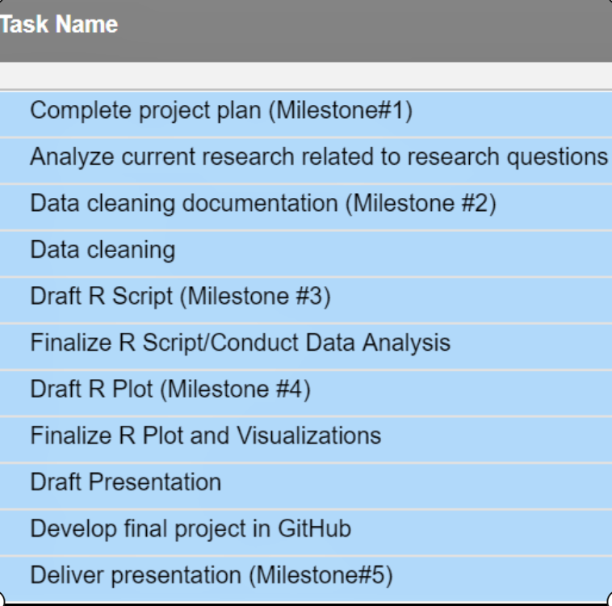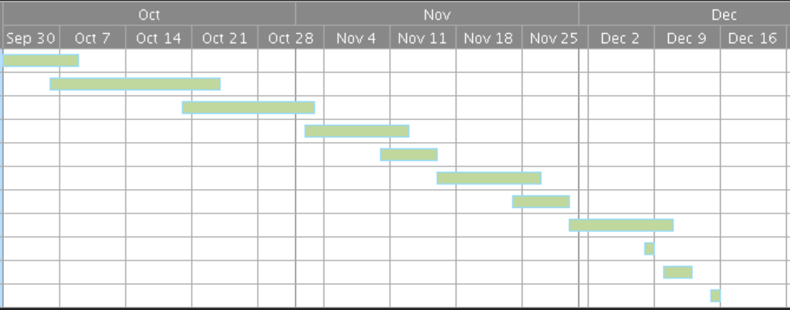

Word Count: 752

## 